HOPEFUL THINKING
This week, I’m hopeful that _____________________________________________________________
_____________________________________________________________________________________
____________________________________________________________________________________.

This summer, I’m hopeful that ___________________________________________________________
____________________________________________________________________________________
____________________________________________________________________________________.

Next school year, I’m hopeful that ________________________________________________________
____________________________________________________________________________________
____________________________________________________________________________________.

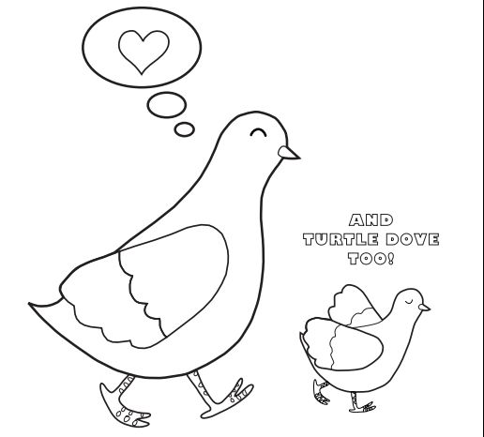

If my hopeful thoughts don’t come true, I can do this to help myself feel better: __________________
____________________________________________________________________________________

