**Public Space**

**6+ Feet**

**(Social Distancing)**

**These are some places where I should practice social distancing:**

**These are the people I should practice social distancing from right now:**

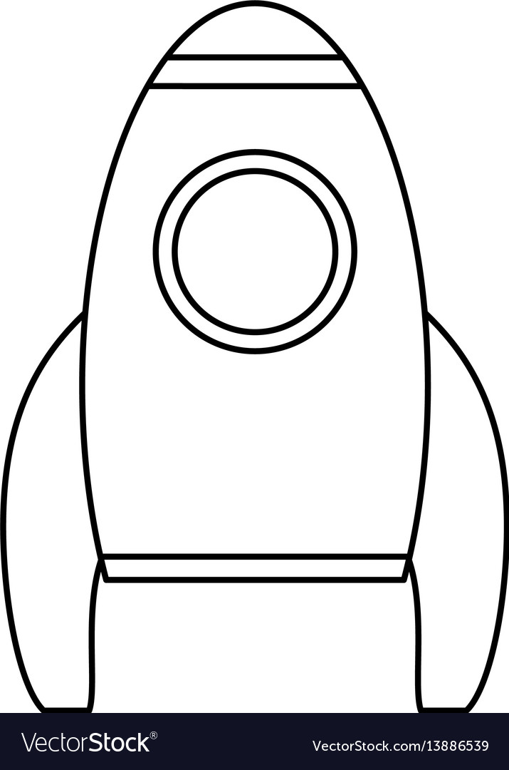

**These are places I should use social space with others:**

**These people might come into my social space:**

**Social Space**

**3-6 Feet**

**This is why they might be allowed in my personal space:**

**These people might be allowed in my personal space:**

**Personal Space**

**0-3 feet**

**ME**